**Assignment 1:**

**Create an infographic illustrating the Test-Driven Development (TDD) process. Highlight steps like writing tests before code, benefits such as bug reduction, and how it fosters software reliability.**

Title: Test-Driven Development (TDD) Process

**1. Introduction to TDD**

Definition: TDD is a software development approach where tests are written before the code is implemented.

Objective: Ensure code reliability, reduce bugs, and streamline the development process.

**2. Key Steps of TDD**

Write Test: Begin by writing a test defining desired functionality.

Run Test: Execute the test to ensure it fails initially.

Write Code: Develop code to pass the test.

Run Test Again: Re-run the test suite to confirm the functionality.

Refactor Code: Optimize code without changing its functionality.

Repeat: Continue the cycle for new features and refactor as needed.

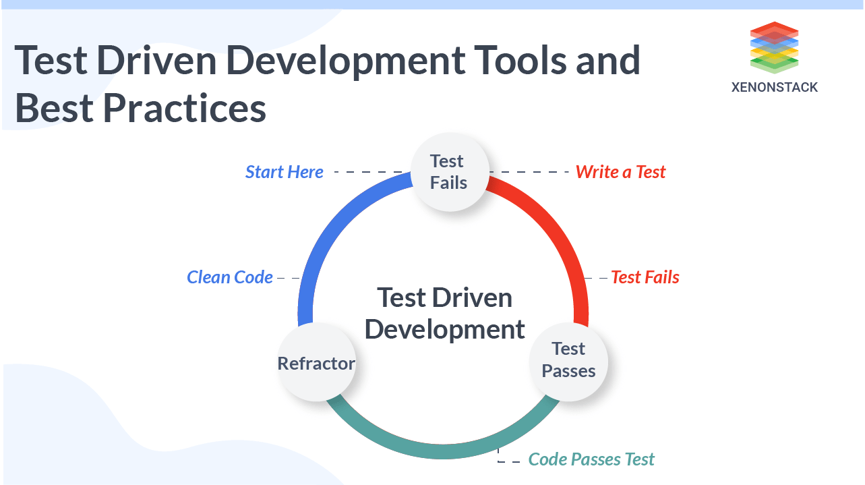

**3. Benefits of TDD**

Bug Reduction: Early bug detection leads to fewer bugs in the final product.

Improved Code Quality: Promotes modular, well-structured code for easier maintenance.

Faster Development: Reduces debugging time, speeding up overall development.

Enhanced Software Reliability: Thorough testing ensures software behaves as expected.

**4. Conclusion**

TDD is a powerful approach for building high-quality software through iterative testing, implementation, and refinement.

**Assignment 2:**

**Produce a comparative infographic of TDD, BDD, and FDD methodologies. Illustrate their unique approaches, benefits, and suitability for different software development contexts. Use visuals to enhance understanding.**

Comparative Infographic: TDD vs BDD vs FDD Methodologies

**1. Test-Driven Development (TDD)**

Approach:

Tests are written before the code is implemented.

Focuses on writing small, incremental tests to drive development.

Benefits:

Early bug detection leads to higher code reliability.

Promotes modular and well-structured code.

Reduces debugging time and speeds up development.

Suitability:

Ideal for projects with evolving requirements and where code quality is crucial.

**2. Behavior-Driven Development (BDD)**

Approach:

Focuses on defining system behavior using scenarios or examples.

Encourages collaboration between developers, testers, and stakeholders.

Benefits:

Ensures alignment with stakeholder expectations.

Promotes a shared understanding of system behavior.

Improves communication and collaboration among team members.

Suitability:

Best suited for projects with complex business logic and extensive stakeholder involvement.

**3. Feature-Driven Development (FDD)**

Approach:

Breaks down development into manageable feature sets.

Emphasizes iterative and incremental delivery of features.

Benefits:

Enhances project visibility and control through feature-based planning.

Facilitates early identification and resolution of issues.

Promotes a disciplined and structured approach to development.

Suitability:

Well-suited for large-scale projects with a focus on feature delivery and incremental development.

**Comparison**

| Aspect | TDD | BDD | FDD |
| --- | --- | --- | --- |
| Approach | Tests written before code. | Behavior-driven scenarios or examples. | Development based on feature sets. |
| Focus | Code implementation details. | System behavior and stakeholder alignment. | Feature delivery and incremental development. |
| Benefits | Early bug detection, code reliability. | Stakeholder alignment, improved communication. | Enhanced project visibility, iterative delivery. |
| Suitability | Evolving requirements, code quality. | Complex business logic, stakeholder involvement. | Large-scale projects, feature-based planning. |

